Name: ______________________________

**Around the World**

**in a Glass Slipper**

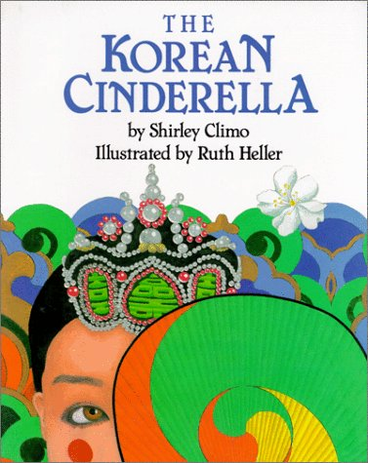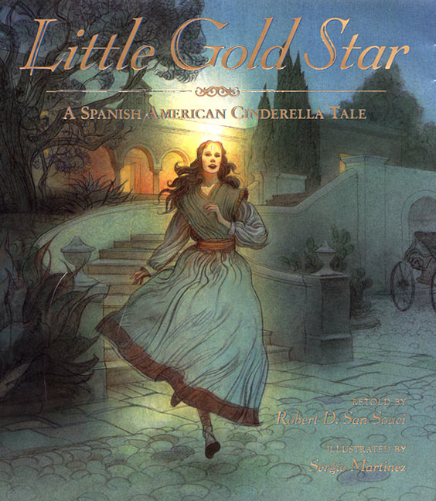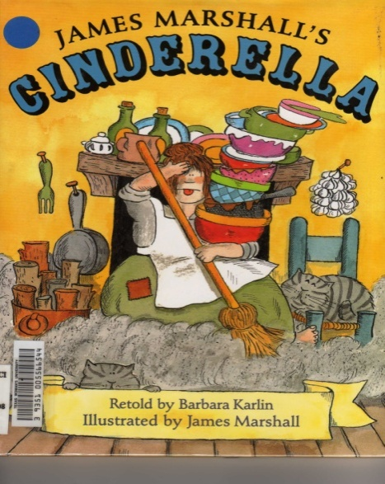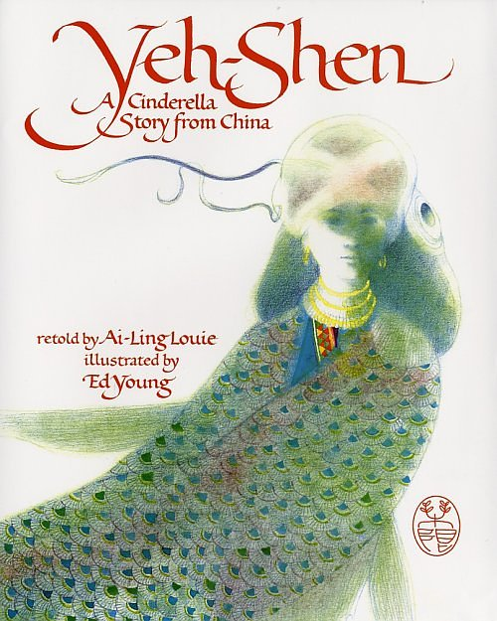

**Table of Contents**

___________________________.....____

___________________________.....____

___________________________.....____

___________________________.....____

___________________________.....____

___________________________.....____

___________________________.....____

___________________________.....____

___________________________.....____

___________________________.....____

___________________________.....____

___________________________.....____

___________________________.....____

___________________________.....____

___________________________.....____

___________________________.....____

___________________________.....____

**Goal:** Before **1 2 3 4**

I can ________________________________

_____________________________________

**Goal:** After **1 2 3 4**

**Apply what you have learned…**

**APK** (What do you already know?)

Date ___________________________

Page number

**New information…**

[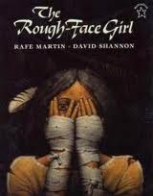](http://www.google.com/url?sa=i&rct=j&q=the+rough+face+girl&source=images&cd=&cad=rja&docid=Sp1Lt-HkxZAkXM&tbnid=JrhXb6N9qux5RM:&ved=0CAUQjRw&url=http://www.tower.com/rough-face-girl-rafe-martin-paperback/wapi/101785126&ei=84RbUdWhNZTW2wWh_IDQDA&bvm=bv.44697112,d.b2I&psig=AFQjCNHJCyONi8ZYxIMUa0B3R_YVzi39ew&ust=1365038676666687)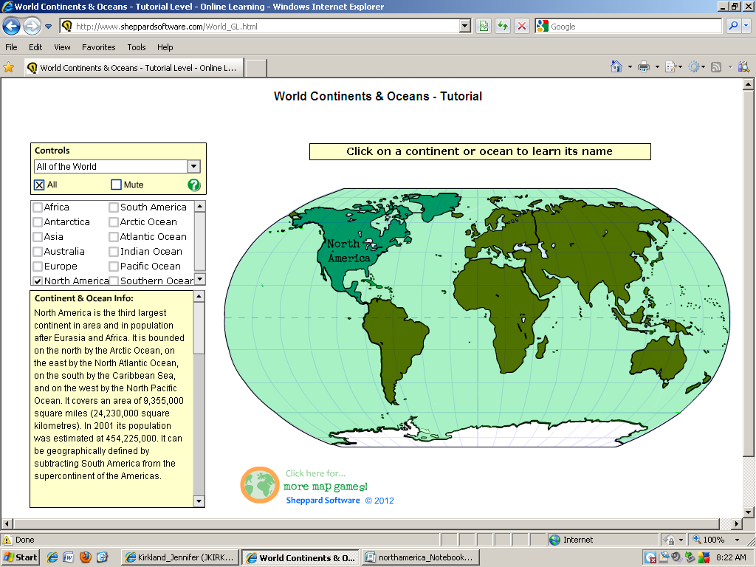

North America

North America

North America

North America

[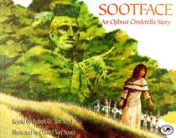](http://www.google.com/url?sa=i&rct=j&q=sootface&source=images&cd=&cad=rja&docid=1KiwRc1dRQrtuM&tbnid=dodUOFNsd7MHYM:&ved=0CAUQjRw&url=http://www.justforkidsbookstore.com/bookcase/cinderellastories/90018.html&ei=G4JbUaymH6rD2QWYk4D4Ag&bvm=bv.44697112,d.aWM&psig=AFQjCNGbqbjm9qMhMvI38tgUwPBMUODEXA&ust=1365037955347935)

North America

North America

North America

North America

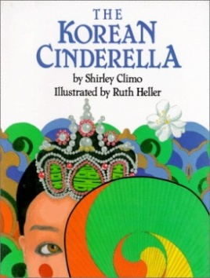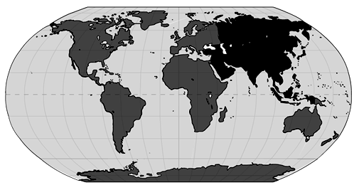

Korea

Korea

Korea

Korea

[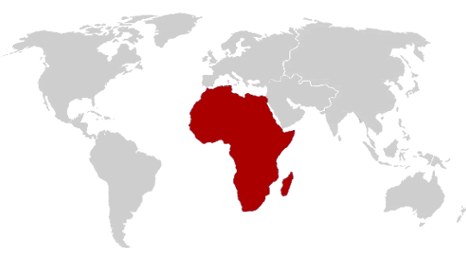](http://www.google.com/url?sa=i&rct=j&q=world+map+with+africa+highlighted&source=images&cd=&cad=rja&docid=B93DrQIZPLj70M&tbnid=YvY0l8u7Qjne4M:&ved=0CAUQjRw&url=http://www.phrs.gr/public/network-africa.aspx&ei=aOpcUZ-OEJHOqAG1poGwBg&bvm=bv.44770516,d.aWM&psig=AFQjCNHq5STOHp9v8n_9Zw_NOwTpxB8s6Q&ust=1365130209686229)[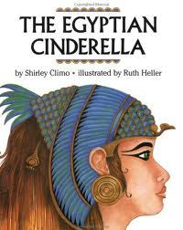](http://www.google.com/url?sa=i&rct=j&q=the+egyption+cinderella&source=images&cd=&docid=zyTqKzVsEb0A3M&tbnid=9hetMJ5uAMvEgM:&ved=0CAUQjRw&url=http://www.kdl.org/categories/616/books/2539&ei=L4RbUeG9EqiU2gWnnoGQDw&bvm=bv.44697112,d.b2I&psig=AFQjCNEisXaq0Lb-EbGDzYs6z-YnPavg_Q&ust=1365038500550835)

Egypt

[](http://www.google.com/url?sa=i&rct=j&q=the+egyption+cinderella&source=images&cd=&docid=zyTqKzVsEb0A3M&tbnid=9hetMJ5uAMvEgM:&ved=0CAUQjRw&url=http://www.kdl.org/categories/616/books/2539&ei=L4RbUeG9EqiU2gWnnoGQDw&bvm=bv.44697112,d.b2I&psig=AFQjCNEisXaq0Lb-EbGDzYs6z-YnPavg_Q&ust=1365038500550835)[](http://www.google.com/url?sa=i&rct=j&q=world+map+with+africa+highlighted&source=images&cd=&cad=rja&docid=B93DrQIZPLj70M&tbnid=YvY0l8u7Qjne4M:&ved=0CAUQjRw&url=http://www.phrs.gr/public/network-africa.aspx&ei=aOpcUZ-OEJHOqAG1poGwBg&bvm=bv.44770516,d.aWM&psig=AFQjCNHq5STOHp9v8n_9Zw_NOwTpxB8s6Q&ust=1365130209686229)

Egypt

Egypt

Egypt

[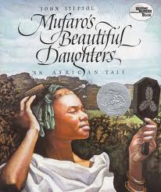](http://www.google.com/url?sa=i&rct=j&q=mufaro's+beautiful+daughters&source=images&cd=&cad=rja&docid=jpe5HG1d_v-lKM&tbnid=MbWCncKQYmMS2M:&ved=0CAUQjRw&url=http://www.harpercollinschildrens.com/books/Mufaros-Beautiful-Daughters/&ei=vYJbUbH-NeT42gWihoDoAg&bvm=bv.44697112,d.aWM&psig=AFQjCNET0h1EH9GboJ4Zw8iiuL5CEwcRxQ&ust=1365038132140195)[](http://www.google.com/url?sa=i&rct=j&q=world+map+with+africa+highlighted&source=images&cd=&cad=rja&docid=B93DrQIZPLj70M&tbnid=YvY0l8u7Qjne4M:&ved=0CAUQjRw&url=http://www.phrs.gr/public/network-africa.aspx&ei=aOpcUZ-OEJHOqAG1poGwBg&bvm=bv.44770516,d.aWM&psig=AFQjCNHq5STOHp9v8n_9Zw_NOwTpxB8s6Q&ust=1365130209686229)

Africa

Africa

Africa

Africa

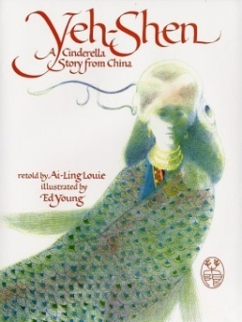

China

China

China

China

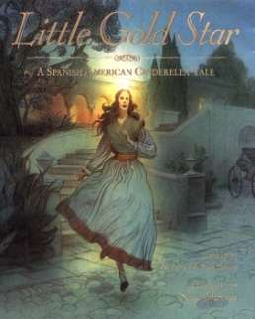[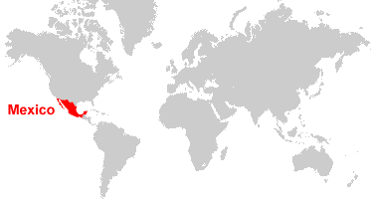](http://www.google.com/url?sa=i&rct=j&q=World+map+mexico&source=images&cd=&cad=rja&docid=6XgRTe0otDagKM&tbnid=h_H6ZjR_HT5V1M:&ved=0CAUQjRw&url=http://geology.com/world/mexico-satellite-image.shtml&ei=oPNcUb3kDM3k2wWqj4DYAQ&bvm=bv.44770516,d.b2I&psig=AFQjCNG45sEAgFeuBM2UPh9H3XY6P2C6lw&ust=1365132563802141)

Mexico

Mexico

Mexico

Mexico

[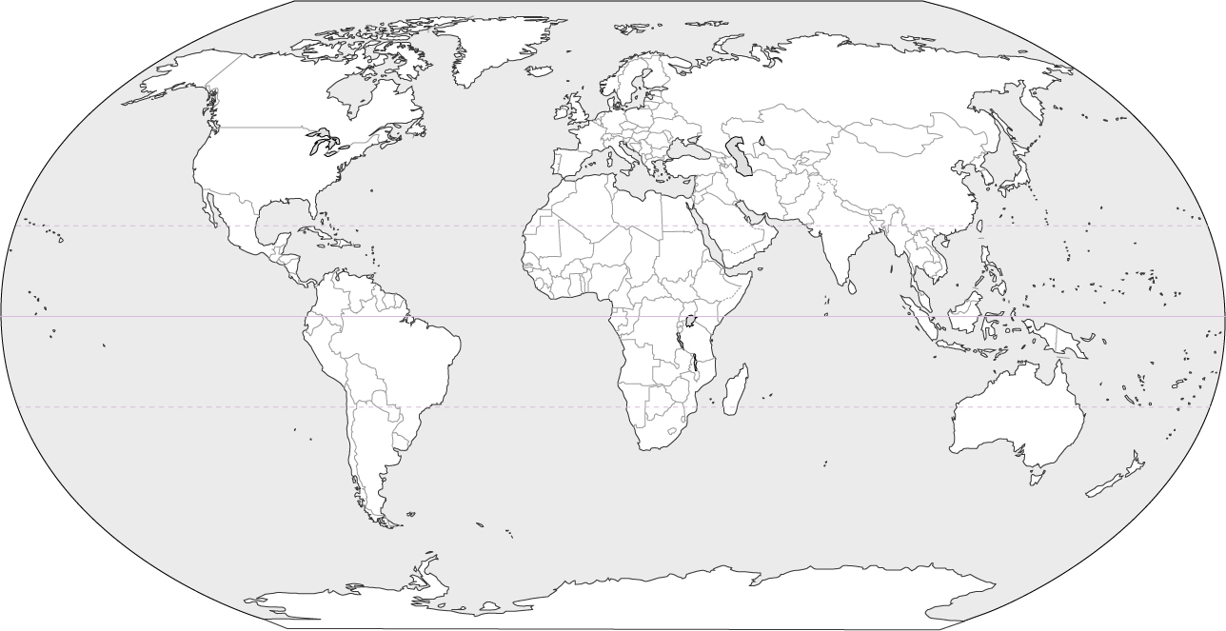](http://www.google.com/url?sa=i&rct=j&q=world+map&source=images&cd=&cad=rja&docid=wqpvw-aJoTjr2M&tbnid=nfVOVzbrvLRY_M:&ved=0CAUQjRw&url=http://www.hdwallpapersfan.com/blank-world-map.html/blank-world-map6&ei=6u9cUdmUAZHOqAG1poGwBg&psig=AFQjCNFJkXeR1zquGlwBCUtF-9t4jwt4Ow&ust=1365131549244474)

World Map

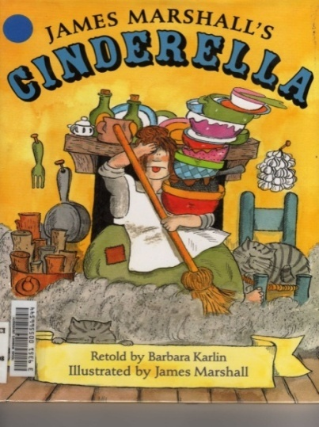

[](http://www.google.com/url?sa=i&rct=j&q=the+rough+face+girl&source=images&cd=&cad=rja&docid=Sp1Lt-HkxZAkXM&tbnid=JrhXb6N9qux5RM:&ved=0CAUQjRw&url=http://www.tower.com/rough-face-girl-rafe-martin-paperback/wapi/101785126&ei=84RbUdWhNZTW2wWh_IDQDA&bvm=bv.44697112,d.b2I&psig=AFQjCNHJCyONi8ZYxIMUa0B3R_YVzi39ew&ust=1365038676666687)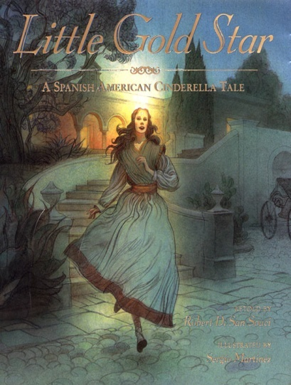

[](http://www.google.com/url?sa=i&rct=j&q=sootface&source=images&cd=&cad=rja&docid=1KiwRc1dRQrtuM&tbnid=dodUOFNsd7MHYM:&ved=0CAUQjRw&url=http://www.justforkidsbookstore.com/bookcase/cinderellastories/90018.html&ei=G4JbUaymH6rD2QWYk4D4Ag&bvm=bv.44697112,d.aWM&psig=AFQjCNGbqbjm9qMhMvI38tgUwPBMUODEXA&ust=1365037955347935)

[](http://www.google.com/url?sa=i&rct=j&q=mufaro's+beautiful+daughters&source=images&cd=&cad=rja&docid=jpe5HG1d_v-lKM&tbnid=MbWCncKQYmMS2M:&ved=0CAUQjRw&url=http://www.harpercollinschildrens.com/books/Mufaros-Beautiful-Daughters/&ei=vYJbUbH-NeT42gWihoDoAg&bvm=bv.44697112,d.aWM&psig=AFQjCNET0h1EH9GboJ4Zw8iiuL5CEwcRxQ&ust=1365038132140195)[](http://www.google.com/url?sa=i&rct=j&q=the+egyption+cinderella&source=images&cd=&docid=zyTqKzVsEb0A3M&tbnid=9hetMJ5uAMvEgM:&ved=0CAUQjRw&url=http://www.kdl.org/categories/616/books/2539&ei=L4RbUeG9EqiU2gWnnoGQDw&bvm=bv.44697112,d.b2I&psig=AFQjCNEisXaq0Lb-EbGDzYs6z-YnPavg_Q&ust=1365038500550835)

[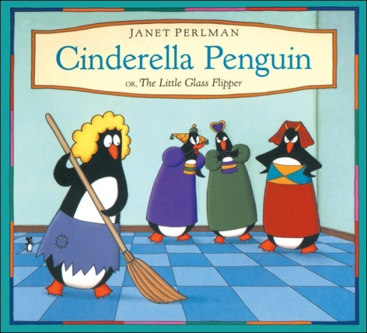](http://www.google.com/url?sa=i&rct=j&q=cinderella+penguin&source=images&cd=&cad=rja&docid=oLWqTKCSGzWwXM&tbnid=-ywFSMPRrT-RiM:&ved=0CAUQjRw&url=http://www.kidscanpress.com/canada/Cinderella-Penguin-P5224.aspx&ei=84pbUfHdC-bE2QXUloDoBA&bvm=bv.44697112,d.b2I&psig=AFQjCNH_G5QuYOPwDL8v2F2_nGmy5pc6iA&ust=1365040237679983)

